CAS PY 106

In-class note 9

1. Charging and discharging a capacitor
2. Storing charge onto a capacitor means we can charge it and then discharge it
3. 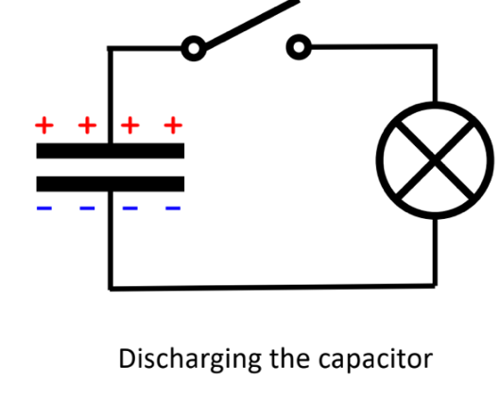
4. Parallel-plate capacitor Equations
5. Q = CV
6. C = k \* e \* A /d
7. U = ½ \* Q \* V
8. Increasing potential difference V
9. A potential difference of 4200V is applied to 54 \* 10^-6 capacitor salvaged from a cardiac defibrillator, and electric potential energy stored is used to explode potato